MallRide Detour in Effect
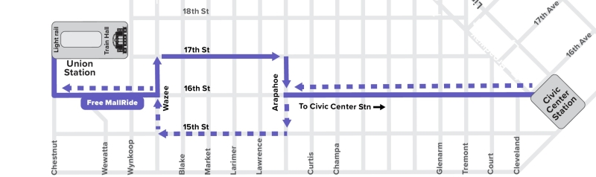
Beginning April 4, RTD's Free MallRide service will detour to avoid construction associated with Denver's 16th Street Mall Project. Construction will occur in phases, with the first phase lasting through June 2022. During this time, MallRide vehicles will detour to 15th and 17th Streets between Wazee Street and Arapahoe Street. See the below map for details of the detour, and click here to learn more about the 16th Street Mall Project.

Schedule
Traveling from one end of Denver's bustling 16th Street Mall to the other, the Free MallRide runs seven days a week and stops on every block between Civic Center Station and Union Station. The Free MallRide starts running at 4:59 a.m. on weekdays, 5:30 a.m. on Saturdays and 6:30 a.m. on Sundays/holidays. Service continues throughout the day with the last complete round-trip of the night starting out at 1:19 a.m. from Union Station to Civic Center Station.

Free MallRide Map: Download PDF map

Weekday
First trip departs Union Station
4:59 a.m.
Free MallRide shuttles run approximately every light cycle during the following high ridership time periods:
6:00 a.m. to 9:00 a.m.
4:00 p.m. to 6:00 p.m.
All other times, Free MallRide shuttles will run from every 3 to 15 minutes.
Last trip departs Union Station
1:19 a.m.

Weekend
First trip departs Union Station
5:23 a.m. on Saturday
6:08 a.m. on Sunday
All weekend Free MallRide shuttles will run from:
every 4 to 15 minutes
Last trip departs Union Station
1:22 a.m. on Saturday, Sunday and holidays
Actual schedules are based on traffic cycles. Times shown are approximate and can be affected by construction, weather, boardings/de-boardings of passengers with mobility aids, special events, etc.

Service Alert
Effective: April 04, 2022 3:00AM - July 01, 2022 2:59AM
MALLRIDE detoured from Mon Apr 4 through Thu Jun 30 due to construction.
As the first phase of construction on the 16th St. Mall begins, MallRide buses will be detouring between Wazee and Arapahoe in both directions. Alternative stops will be along 15th (towards Union Station) & 17th (towards Civic Center), affected stops are listed below.
Affected stops:
16th Street Mall & Blake St (#33570) (civic ctr)
16th Street Mall & Market St (#34380) (civic ctr)
16th Street Mall & Larimer St (#22351) (civic ctr)
16th Street Mall & Lawrence St (#22352) (civic ctr)
16th Street Mall & Arapahoe St (#22353) (civic ctr)
16th Street Mall & Arapahoe St (#22371) (union stn)
16th Street Mall & Lawrence St (#22372) (union stn)
16th Street Mall & Larimer St (#22373) (union stn)
16th Street Mall & Market St (#34381) (union stn)
16th Street Mall & Blake St (#34379) (union stn)
Alternative Stops:
Civic Center bound:
17th St & Wazee St
17th St & Blake St
17th St & Larimer St
17th St & Lawrence St
17th St & Arapahoe St
Union Station bound:
15th St & Arapahoe St
15th St & Lawrence St
15th St & Market St
15th St & Blake St

Another Downtown Option: the Free MetroRide
We've added a brand new free bus service downtown to complement the Free MallRide: The Free MetroRide. This service offers weekday rush hour service between Union Station and Civic Center Station, making limited stops along 18th and 19th Streets.
Learn More About the Free MetroRide

